**From:** <[tcgorham@midco.net](mailto:tcgorham@midco.net)>

**Subject: Support for Gateway Trail Expansion**

**Date:** February 7, 2020 at 7:44:46 PM CST

**To:** <[rep.bob.dettmer@house.mn](mailto:rep.bob.dettmer@house.mn)>

**Cc:** <[c.maefsky@ci.scandia.mn.us](mailto:c.maefsky@ci.scandia.mn.us)>, "'p.ray'" <[p.ray@ci.scandia.mn.us](mailto:p.ray@ci.scandia.mn.us)>, "'Janie O'Connor'" <[janie.oconnor@icloud.com](mailto:janie.oconnor@icloud.com)>, "'Dustin'" <[dhegland@aol.com](mailto:dhegland@aol.com)>, "'Cami Van Abel'" <[cavanabel@gmail.com](mailto:cavanabel@gmail.com)>, "'Carol Schwinghammer'" <[clschwing@gmail.com](mailto:clschwing@gmail.com)>, <[moneyman@frontier.com](mailto:moneyman@frontier.com)>

I am writing today on behalf of the Parks and Recreation Committee of the City of Scandia.

First, I would like to thank you for your support thus far of the expansion of the popular Gateway Trail connection from Marine on St. Croix through William O’Brien State Park to Scandia.  Your continued support and encouragement of your fellow legislators is critical to the passage of the bill to fund the effort.

Our committee is excited for this phase of the expansion, and, eventually, building a link from our rural and historic small town to the proud capital city of St. Paul, highlighting miles of scenic rural and urban landscapes in between.  This trail will represent both a destination as part of Scandia’s healthy cycling initiative and a natural origination for access to the Gateway and Browns Creek trails.  Cyclists, hikers, runners, skiers, and horse lovers will be drawn to this trail.

This next step of bringing the trail into Scandia will allow access from William O’Brien to the Scandia village center.  The village center area includes playgrounds, tennis / pickleball courts, a skating rink, multiple sports fields, restaurants and other commercial facilities.  Other attractions in the area include the Hay Lake School Museum, the monument to Minnesota’s first Swedish Settlers, and the Gammelgarden Museum.

Our committee is dedicated to making our community both a great place to live and a fun place to visit.  Our charter includes support of Scandia’s efforts to enhance the economic viability of northern Washington county.  This trail augments our efforts to develop parks and heathy outdoor recreation activities for its citizens and visitors.  Our community has expressed great interest in its potential.

Again, thank you for your support thus far.  We hope you will extend that support by carrying forward this bill.

Sincerely,

The Scandia Parks and Recreation Committee

Terry Gorham, Committee Chair

Carol Schwinghammer

Cami Van Abel

Greg Zauner

Dustin Hegland

Patti Ray, Scandia City Council

**From:** Ted Kluznik <[tkluznik@msn.com](mailto:tkluznik@msn.com)>

**Subject: Gateway Trail To Scandia**

**Date:** February 4, 2020 at 7:06:09 PM CST

**To:** "[Sen.karin.housley@senaate.mn](mailto:Sen.karin.housley@senaate.mn)" <[Sen.karin.housley@senaate.mn](mailto:Sen.karin.housley@senaate.mn)>

**Cc:** "[c.maefsky@ci.scandia.mn.us](mailto:c.maefsky@ci.scandia.mn.us)" <[c.maefsky@ci.scandia.mn.us](mailto:c.maefsky@ci.scandia.mn.us)>, "[janie.oconnor@icloud.com](mailto:janie.oconnor@icloud.com)" <[janie.oconnor@icloud.com](mailto:janie.oconnor@icloud.com)>, "[drlindeke@comcast.net](mailto:drlindeke@comcast.net)" <[drlindeke@comcast.net](mailto:drlindeke@comcast.net)>

Dear Senator Housley,

I am writing to request your support in passing the Bill titled, "Gateway Trail To Scandia".

I am an avid cyclist and regularly ride the Gateway Trail. I believe that the parks and trails of Minnesota make this state the special place to live that it is and that such amenities provide a recreational outlet for all people, especially  our youth. I believe that completing this trail would positively contribute to the health and mood of all of all our citizens and further that trails such as this create an attractive environment for our economy as well by helping our great Minnesota companies attract and retain talented employees. We live in a cold Northern climate without mountains or oceans in the middle of a continent but this is our means to differentiate ourselves in a positive manner.

Thank-you for supporting the Gateway Trail To Scandia. Projects such as this make Minnesota the wonderful place to live that it is and legislators like you enable us to be this special place.

Very Truly Yours,

Theodore Kluznik

1448 Park Hills Court

Woodbury, MN 55125

phone: 651-738-9302

**From:** Scott Eggert <[skeggert@yahoo.com](mailto:skeggert@yahoo.com)>

**Subject: Gateway Trail to Scandia**

**Date:** January 31, 2020 at 11:34:53 PM CST

**To:** [rep.bob.dettmer@house.mn](mailto:rep.bob.dettmer@house.mn), [sen.karin.housley@senate.mn](mailto:sen.karin.housley@senate.mn)

**Cc:** [c.maefsky@ci.scandia.mn.us](mailto:c.maefsky@ci.scandia.mn.us), [janie.oconnor@icloud.com](mailto:janie.oconnor@icloud.com), Dennis Lindeke <[drlindeke@comcast.net](mailto:drlindeke@comcast.net)>

Please support the $4.6 million state funding request for final design and construction of the 3-mile segment of the Gateway Trail between William O'Brien State Park and the City of Scandia.

My family, friends, neighbors and coworkers ride the Gateway Trail an average of about 3 times per week during the summer for exercise and recreation, including rides to Pine Point Park or into Stillwater. Enabling riders to safety bike on the trail extension to Marine on the St. Croix and Scandia has been needed for decades, and will provide benefits to businesses, citizens and tourists.

This 3-mile segment extension of the Gateway Trail between William O'Brien State Park and the City of Scandia will connect with an existing link to the nearby City of Marine on St. Croix.  The route for this section has been determined and all property easements are secured.  The City of Scandia is taking the lead on this project, with support from Cycling Scandia, the Gateway Browns Creek Trail Association, and several other groups.

Many sections of the remaining 6-miles of planned trail between Pine Point Park and William O'Brien have been defined and secured, however, proposed construction will be some time in the future.

Thanks for your support and leadership.

Keeping families healthy and safe is good business.

The Eggert Family and Friends

Scott Eggert

Bicycle Alliance of Minnesota (BikeMN) Board Member

<http://linkedin.com/in/skeggert>

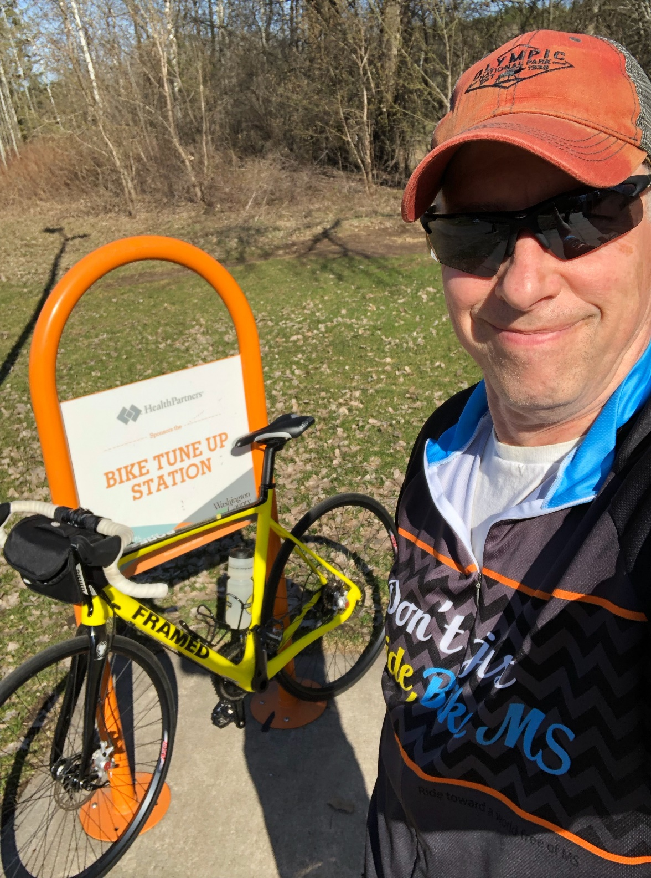

**From:** Kerri Kolstad <[kerri@mywahooadventures.com](mailto:kerri@mywahooadventures.com)>   
**Sent:** Thursday, January 30, 2020 10:47 AM  
**To:** [rep.bob.dettmer@house.mn](mailto:rep.bob.dettmer@house.mn)  
**Cc:** Kerri Kolstad <[kerri@mywahooadventures.com](mailto:kerri@mywahooadventures.com)>  
**Subject:** Support for Gateway Trail to Scandia

Dear Representative Dettmer.

As the owner of an outdoor tour company in Washington County and Secretary of the Board of the Gateway Brown’s Creek Trail Association, I would like to thank you for authoring the bill for the $4.6 million Gateway to Scandia trail connection and appreciate that you are just as excited and supportive as many trail enthusiast’s I meet along the trail.  Having bicycled, walked, snowshoed, or jogged along many of the state trails in Minnesota you see how they help build strong and vibrant communities.  Minnesota continues to consistently rank in the top 3 states for cycling and adding to our trail network will only draw more and more visitors to our state to enjoy these trails and spend their dollars in these communities as well!

As you may know, many of the sections of the remaining 7-miles of planned trail between Pine Point Park and William O'Brien have been defined and secured, so we are getting closer and closer to reality!

Let me know how I can help be a part of this significant trail connection.

Kerri Kolstad

Kerri Kolstad

Founder

651.280.7299

[www.mywahoodadventures.com](http://www.mywahoodadventures.com/)



**From:** Lynn Hamlin <[lynn@maklinbikeshop.com](mailto:lynn@maklinbikeshop.com)>

**Subject: Gateway State Trail expansion to Scandia**

**Date:** January 28, 2020 at 1:10:23 PM CST

**To:** [sen.karin.housley@senate.mn](mailto:sen.karin.housley@senate.mn), [rep.bob.dettmer@house.mn](mailto:rep.bob.dettmer@house.mn)

**Cc:** [c.maefsky@ci.scandia.mn.us](mailto:c.maefsky@ci.scandia.mn.us), [janie.oconnor@icloud.com](mailto:janie.oconnor@icloud.com)

Dear Senator Karin Housley & Representative Bob Dettmer,

My husband and I live in North Branch, MN and in October 2019 opened a bike shop in Shafer, MN. One of the reasons we picked the area for our new bike shop was because it is about 100 yards from the Swedish Immigrant Regional Trail, a safe place for customers to test ride bikes and ride without having to worry about street traffic and other distractions. Owning a bike shop, we have seen many customers who have not been on a bike in over 20 years, get back into biking because of the growing accessibility of bike trails. Without these safe bike trails, people would be afraid to get out and ride. These same customers are planning trips out of their local area with their bikes so they can explore more on their bikes and check out new trail systems, enjoying other areas in our state and adding tourism dollars into many communities - a win-win for everyone!

We have two sons ages 12 and 10 who love to bike. They love biking so much, that you could find them on their mountain bikes and cyclocross bikes racing throughout the summer and fall seasons. Finding safe places to ride is a priority for us, and why we ask you to support the expansion of the Gateway State Trail to allow families a safe place to bring their children to bike, creating a lifelong love for biking and exercise.

Thank you for your support you have already given to this bill, and hope that you continue your support by moving this bill forward to expand the Gateway State Trail to Scandia….giving Minnesota more miles of safe places to ride bikes.

-Lynn

Lynn Hamlin

Owner

Maklin Bike Shop

[maklinbikeshop.com](http://maklinbikeshop.com/)

(651) 247-8614

30235 Redwing Ave

P.O. Box 191

Shafer, MN 55074

**From:** Mary Hooley <[maryhooley@gmail.com](mailto:maryhooley@gmail.com)>

**Subject: Gateway State Trail improvements**

**Date:** January 28, 2020 at 6:32:43 AM CST

**To:** "Sen. Karin Housley" <[sen.karin.housley@senate.mn](mailto:sen.karin.housley@senate.mn)>, Bob Dettmer <[rep.bob.dettmer@house.mn](mailto:rep.bob.dettmer@house.mn)>

**Cc:** "Janie O'Connor" <[janie.oconnor@icloud.com](mailto:janie.oconnor@icloud.com)>, Christine Maefsky <[c.maefsky@ci.scandia.mn.us](mailto:c.maefsky@ci.scandia.mn.us)>

Dear Senator Housley and Representative Dettmer,

I would like to thank you both for your support and work on efforts to extend and improve the Gateway State Trail through William O'Brien State Park and into the City of Scandia.  I am a resident of Scandia, and a member of its Friends of Scandia Parks and Trails group, as well as a volunteer for the Marine Community Library.   I grew up in Marine, and moved back to the area (from Missouri) with my husband when we retired five years ago, owing to its exceptional natural beauty and many opportunities for outdoor recreation.  We are so glad we did!

This proposed trail extension would create superb and much-used recreational opportunities for our area, in my opinion, and would take advantage of a most beautiful and beloved part of the St.Croix valley area.   I personally love the idea of a trail that would be so accessible to so many people and would bring exquisite natural beauty to residents and to visitors here.

I believe the benefits are many and are significant.   In a nutshell, they include health benefits to those who would use the trails and economic benefits to the communities involved---in this case, particularly Scandia and Marine on St. Croix.

I am very hopeful that you will continue to support this project.    I am so grateful to you both for your crucial work on this project, which I consider an invaluable future asset to us all.

Sincerely,

Mary Hooley

14241 205th St. N.

Scandia, MN   55073

[maryhooley@gmail.com](mailto:maryhooley@gmail.com)

651-373-7183

--

651-373-7183 (c)

**From:** Greg Swanson <[gr_swanson@comcast.net](mailto:gr_swanson@comcast.net)>

**Subject: "Gateway Trail to Scandia" Bonding Bill**

**Date:** January 20, 2020 at 7:01:11 PM CST

**To:** [sen.karin.housley@senate.mn](mailto:sen.karin.housley@senate.mn)

**Cc:** [drlindeke@comcast.net](mailto:drlindeke@comcast.net), [c.maefsky@ci.scandia.mn.us](mailto:c.maefsky@ci.scandia.mn.us), [janie.oconnor@icloud.com](mailto:janie.oconnor@icloud.com)

**Reply-To:** Greg Swanson <[gr_swanson@comcast.net](mailto:gr_swanson@comcast.net)>

Dear Senator Housley,

       I am writing to express my strong support for the proposed State funding for final design and construction of a 3-mile segment of the Gateway Trail between William O'Brien State Park and the City of Scandia.  This will connect with an existing link to the nearby City of Marine on St. Croix.

      I am a 70 year old retiree, and have become very active in the Twin Cities bicycling scene.  I can strongly attest to the benefits of bicycling as relates to leading an active lifestyle.  I belong to two bike clubs (Hiawatha Bicycling Club, and Twin Cities Bicycling Club), of which we have about 2,000 total members.  Club rides often including riding in the northern Washington County area.  For instance, we will often start from the Lake Elmo area, and then ride north to Scandia and Marine on St. Croix.  Extending/improving the Gateway trail would be a tremendous boost to riding in this area.

       Please support this initiative.  It will be money well spent!

Thanks,

Greg Swanson

Oakdale, MN

Begin forwarded message:

**From:** Mary Hoff <[hoff001@gmail.com](mailto:hoff001@gmail.com)>

**Subject: Gateway Trail to Scandia**

**Date:** January 19, 2020 at 8:32:52 PM CST

**To:** "Sen. Karin Housley" <[sen.karin.housley@senate.mn](mailto:sen.karin.housley@senate.mn)>

**Cc:** [c.maefsky@ci.scandia.mn.us](mailto:c.maefsky@ci.scandia.mn.us), [janie.oconnor@icloud.com](mailto:janie.oconnor@icloud.com), "Lindeke, Dennis" <[drlindeke@comcast.net](mailto:drlindeke@comcast.net)>

Senator Housley,

I'm writing to express my support for funding to construct the Gateway Trail segment between William O'Brien State Parkand Scandia.

As a longtime area resident, I know how valued and well-used William O'Brien and recreational trails are in our area and what important roles they play in the health and well-being of myself, friend and neighbors, and visitors from the Twin Cities and beyond.

This much-needed trail segment will make these public treasures more attractive and accessible and boost economic activity in our communities. It also will contribute to the exciting goal of connecting the Twin Cities to Duluth via a nonmotorized trail, which would open a whole new universe of recreational opportunities and tourist appeal along the Minnesota–Wisconsin border.

Land rights are in place and the project is shovel ready. I strongly encourage you to make this dream a reality with your support for the $4.6 million requested to complete it.

Thank you,

Mary Hoff

--  
Mary Hoff

8047 80th St. N

Stillwater MN 55082

[hoff001@gmail.com](mailto:hoff001@gmail.com)

651-303-3089

@mkhoff

Begin forwarded message:

**From:** Dennis Lindeke <[drlindeke@comcast.net](mailto:drlindeke@comcast.net)>

**Subject: Gateway Trail to Scandia Bonding Bill**

**Date:** January 17, 2020 at 4:21:04 PM CST

**To:** [rep.bob.dettmer@house.mn](mailto:rep.bob.dettmer@house.mn)

**Cc:** [c.maefsky@ci.scandia.mn.us](mailto:c.maefsky@ci.scandia.mn.us), [janie.oconnor@me.com](mailto:janie.oconnor@me.com), Lisa Philippi <[lisa.philippi@gmail.com](mailto:lisa.philippi@gmail.com)>

**Reply-To:** Dennis Lindeke <[drlindeke@comcast.net](mailto:drlindeke@comcast.net)>

Representative Dettmer;

On behalf of the Gateway Browns Creek Trail Association (GBCTA), I am writing to pledge our support for the proposed 2020 Governor's Bonding Bill.  Including the $4.6 million request for the Gateway Trail to Scandia extension.

The GBCTA, along with the MN DNR and Parks and Trails Council of Minnesota, has been working for over 20 years on a proposed 10-mile route for the Trail between Pine Point Park and Scandia.  At this point in time, a 3-mile segment between William O'Brien State Park and the City of Scandia is 'shovel ready'.  It will be exciting to connect these locations, along with the nearby City of Marine on St. Croix; which has an existing trail to the State Park.

Thank you very much for working with the City of  Scandia, the DNR and local citizens to make this happen.

Dennis Lindeke

President

GBCTA

Begin forwarded message:

**From:** Derek Otto <[Derek.Otto@ymcamn.org](mailto:Derek.Otto@ymcamn.org)>

**Subject: Re: In support for Gateway to Scandia bonding bill**

**Date:** January 17, 2020 at 2:44:40 PM CST

**To:** "[Rep.bob.dettmer@house.mn](mailto:Rep.bob.dettmer@house.mn)" <[Rep.bob.dettmer@house.mn](mailto:Rep.bob.dettmer@house.mn)>

**Cc:** "[c.maefsky@ci.scandia.mn.us](mailto:c.maefsky@ci.scandia.mn.us)" <[c.maefsky@ci.scandia.mn.us](mailto:c.maefsky@ci.scandia.mn.us)>, "[Janie.oconnor@icloud.com](mailto:Janie.oconnor@icloud.com)" <[Janie.oconnor@icloud.com](mailto:Janie.oconnor@icloud.com)>

Dear Representative Dettmer,

I am the Executive Director of the YMCA Forest Lake, located in Forest Lake, Minnesota. I am writing to urge your support for the Gateway to Scandia bonding bill, which will provide funding to complete a portion of the Gateway Trail from William O’Brien State Park to the City of Scandia.

This Gateway Trail extension will provide bike and walking access to our entire community to the amenities available in Scandia that would otherwise require driving. The Gateway Trail is already Minnesota’s most popular bike trail and this additional 3 miles would encourage families, cycling enthusiasts, and those new to outdoor exercise, to utilize the sports facilities, skating rink, restaurants, and other commercial businesses that Scandia offers, boosting the local economy as well as encouraging healthy activity for all. This trail extension would provide a safer and more usable option for children and disabled individuals who would like to take advantage of this beautiful passage. The benefits of outdoor exercise are innumerable and we at the YMCA Forest Lake cannot overstate our encouragement in taking advantage of the parks, trails, and other amenities offered by our state.

Please do not hesitate to reach out with questions or if additional information is needed. Thank you in advance for your support of the Gateway to Scandia bonding bill, and your commitment to moving this bill through the next legislative session.

Sincerely,

**Derek Otto**

**Executive Director**

YMCA Forest Lake

YMCA OF GREATER TWIN CITIES

19845 Forest Rd N, Forest Lake MN 55025

(P)  763-717-1836

(W)  [www.ymcatwincities.org](http://www.ymcatwincities.org/)

[Watch our video](http://www.youtube.com/watch?v=7RiAhi_E83Y&feature=share&list=UUEQ-Obuyfp59gkvLyGfcKDQ) | [Donate](x-msg://33/ymcamn.org/give)| [Web](x-msg://33/ymcamn.org/forestlake) | [Facebook](https://www.facebook.com/ymcaforestlake/) | [Twitter](http://twitter.com/ymcatwincities) | [YouTube](http://www.youtube.com/user/YMCATwinCities)

**The Y:  We're for Youth Development, Healthy Living, and Social Responsibility.**